Group Members Names And ID’s:
Syed Hussain Ali Rizvi (15785)
Humza Ahmed (15841)
Muhammad Ahmer (15612)

Mobile Action.Com
Test Plan on Mobile Action.com:
Webite URL:

https://github.com/ShuvoProgram/SQA-Manual-Testing/tree/main?tab=readme-ov-file

https://www.mobileaction.co/
Purpose of the Test Plan:
The aim of this test plan is to verify the mobile action. com "It's a joy to read." --Read Between the Lines .The [pohlmanink. We are concentrating on things like UI testing, Responsiveness, Navigation, Forms, Usability in general in order to provide a consistent User experience.
Objectives:
- Make sure all core functionalities (login, register, navigation, contact forms, etc.) of your landing page are traceable and fully functioning.
- Make sure the site is mobile-friendly.
- Test in multiple browsers to ensure compatibility.
Tools Used:
Although the file doesn’t directly mention tools, based on the test approach, the following tools are either used or recommended:
Bug Tracking Tool (e.g., JIRA, Trello, Bugzilla):
To report and track defects.
Mobile Device Emulators or BrowserStack:
To simulate tests on real mobile devices
If automation is needed in the future, tools such as Selenium, Appium, or TestNG can be integrated.
Testing Framework Used:
- Test Scenario: Describes the overall function or feature to be tested.
- Test Cases: Specific conditions and steps for each scenario.
- Expected Result: What the system should do if working correctly.
- Actual Result: What actually happens during testing.
- Status: Indicates whether the test passed or failed.
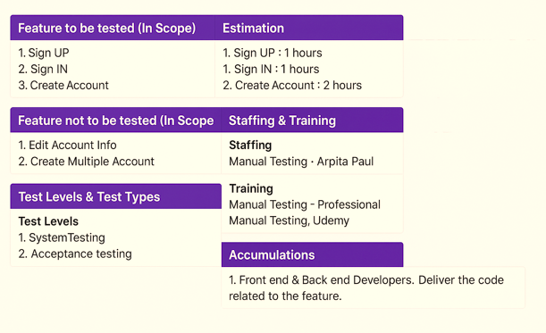

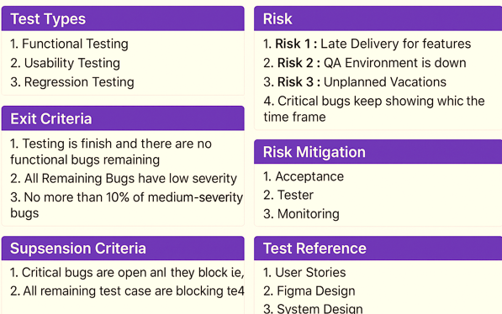

Test Status:
- Each test case has an “Actual Result” and “Status” field to track outcome (Pass/Fail).
- Status updates help in identifying which features are stable and which need fixes.
Test Case on Mobile Action.com:
Manual Testing:
Manual testing is the process of manually testing software for defects. It requires a tester to play the role of an end user whereby they use most of the application's features to ensure correct behavior.
Our experiments center on user registration for Mobile Action. com, detailing various sign-up options. Here is a basic guide:
Overall Results:
Total Test Cases: 14
Passed: 4
Failed: 10
Issues Identified:
LinkedIn Sign-up Issues: Several test cases were failing due to verification code related problems, incorrect field handling and account creation issues.
Email Validation Errors: A few emails were prevented incorrectly from being accepted.
Google Sign-up Worked Well: No issues were found in Google account registration.
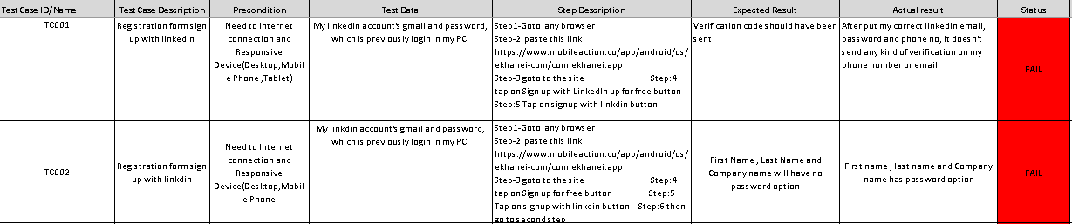
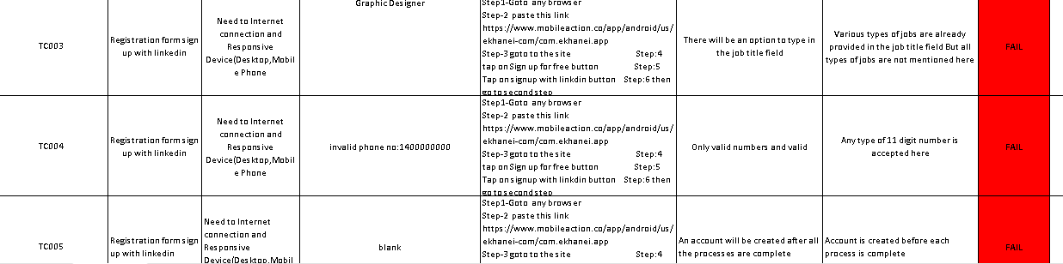
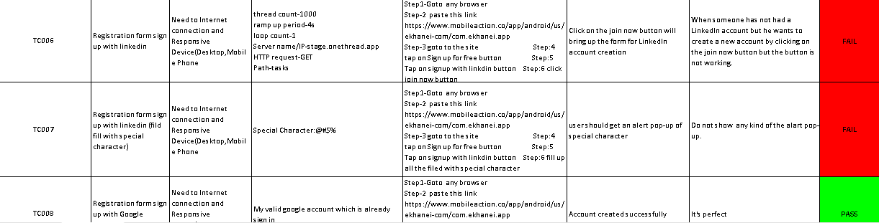
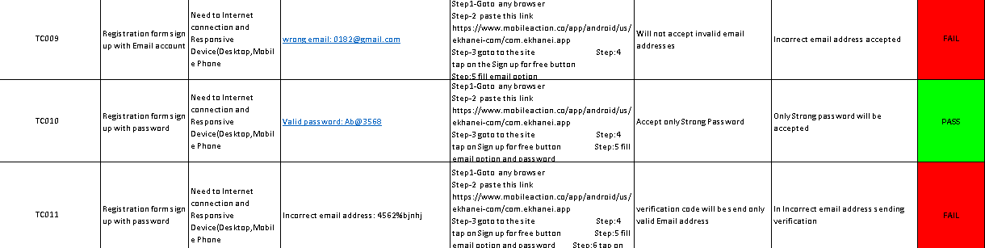
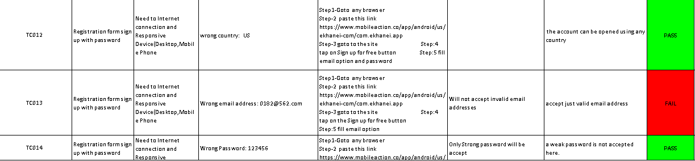
Recommendations:
- Investigate LinkedIn integration issues to ensure proper verification and account creation.
- Improve email validation to reject incorrect addresses.
- Review field constraints, such as special characters and job title selections, to meet expected behavior.
Issues Found In Bug:
- Missing or Incorrect Logos: Some logos (Facebook, Instagram, and YouTube) are missing from the header and footer.
- Feature Errors: Certain features like call buttons, chat options, and form sections are either missing or incorrectly placed.
- Color & Font Issues: Some features (e.g., “Free Ortho Consult”) have incorrect colors, and text formatting doesn’t match expected designs.
- Wrong Contact Details: Phone numbers, contact hours, and location details don’t match the provided reference (Figma).
- Extra or Incorrect Information: Unnecessary text, images, and links are appearing where they shouldn’t be, deviating from the original design.
- Misaligned Content: Sections like doctor details, treatment descriptions, and footer alignment are not properly positioned.
Priority Breakdown:
- High Priority: Missing essential features, incorrect contact details, and misplaced elements.
- Medium Priority: Logo availability, rotated images, and text formatting errors.
- Low Priority: Background colors, footer section details, and minor alignment issues.
For Mobile:
High:


Medium:


(Low):


For Tabs:
High:
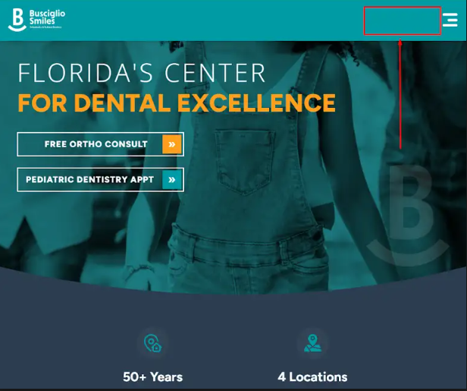

Medium:
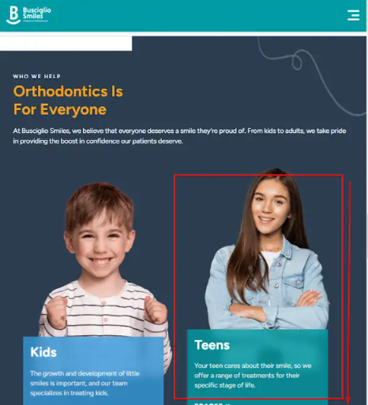

Low:
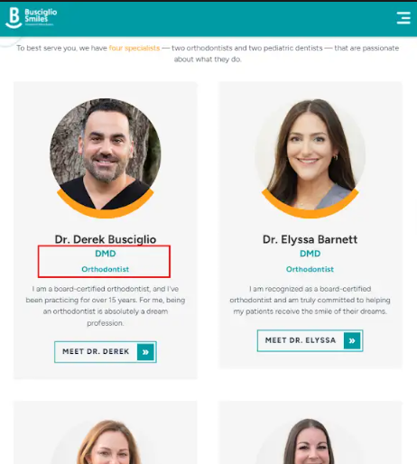

The bug report identifies the final result will be:Corrected Header & Footer: Missing logos will be restored, and alignment issues will be fixed. Accurate Contact Information: Phone numbers, contact hours, and location details will match the Figma reference.Properly Functioning Features: Missing buttons, forms, and call/chat options will be available.
User Interface(UI):
A user-friendly and data-driven interface, but minor refinements could further enhance usability and efficiency.
It is a platform designed for app store optimization (ASO), competitor analysis, and market intelligence. The user interface (UI) plays a crucial role in ensuring smooth navigation and accessibility for users managing their app marketing strategies.
Strengths of the UI:
Intuitive Navigation: The menu and dashboard are well-arranged, allowing users to access reports, analytics, and campaign management features efficiently. Responsive Design: The UI adapts well across different devices, ensuring a seamless experience on desktops, tablets, and mobile phones.
Data Visualization: Charts, graphs, and reports are presented in a visually appealing manner, making complex data easy to interpret.
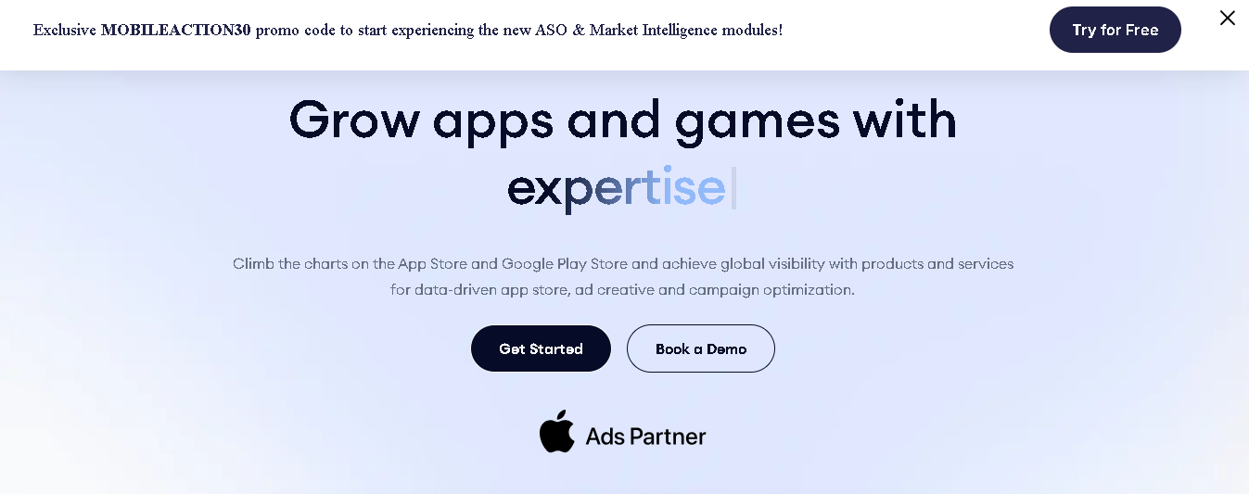
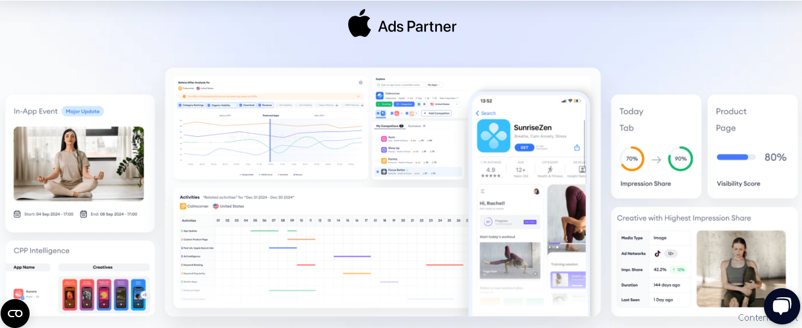



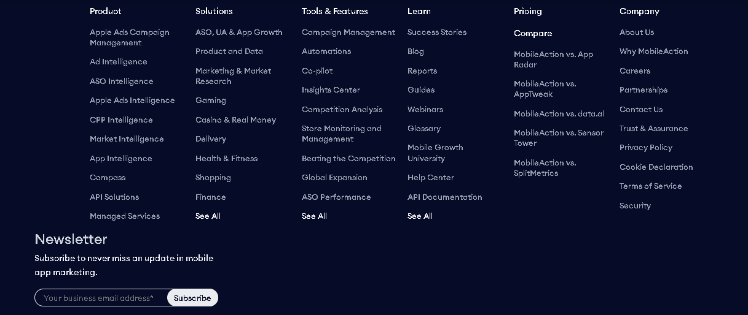
For Improvement:
Feature Accessibility: Some advanced features require multiple clicks to access, which could be streamlined for better usability.
Loading Speed: Certain sections, especially data-heavy reports, may take longer to load, impacting user experience.
Application Programming Interface (APIS):
APIs are accessible way to extract and share data within and across organizations.
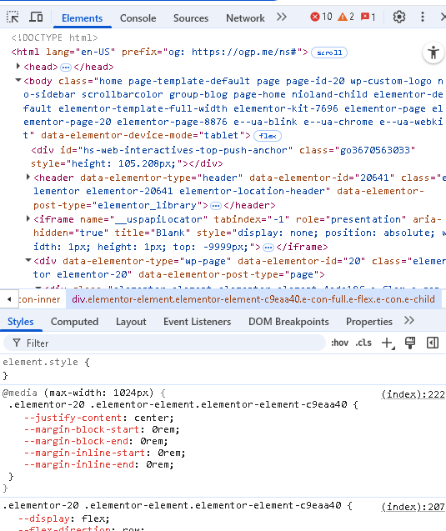
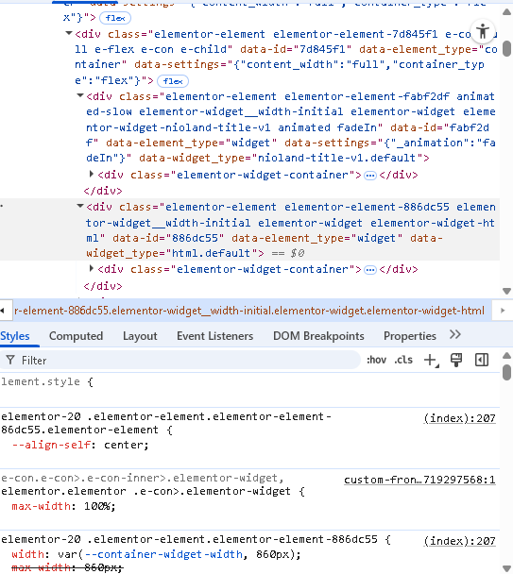
API Integration and Purpose:
MobileAction is a top App Store Optimization (ASO) and app marketing platform that offers data-driven services to mobile app developers and marketers. It was established in 2013 in San Francisco and currently assists more than 300,000 app developers and is relied upon by industry leaders like Entain, IGG, Zalando, Playtika, and Adidas. Its flagship API, the MobileAction API, is a central part of its product set, providing transparent integration of app insight, market data, and analytics into third-party dashboards and workflows for data-driven decision-making. The API is built to improve user acquisition (UA), track app performance, and offer competitive intelligence for apps in the App Store and Google Play Store.
Major use for the MobileAction API are:
Real-Time Analytics Access: Retrieve fresh metrics on app performance, market trends, and user behavior.
Campaign Optimization: View Apple Search Ads campaign performance, such as keyword performance, bid history, and ad creatives.
Competitor Monitoring: Track competitors' ad creatives, keyword strategies, and market positioning.
Keyword and ASO Insights: Access keyword rankings, search volumes, and metadata to enhance app store visibility.
Custom Reporting: Create customized reports in accordance with unique KPIs and metrics.
User Feedback:
Positive Feedback:
Users praise MobileAction for its accurate keyword rankings, detailed ASO reports, and Apple Search Ads analytics. The platform has been described as a game-changer for ASO and UA, with clients reporting a 45% increase in app downloads and an 84% improvement in session numbers.
Pricing:
MobileAction has multiple plans available, including a free limited-feature plan and an Enterprise plan for more complex requirements. The specific prices are not publicly stated and need to be requested from MobileAction for a custom breakdown. . For more information, visit https://www.mobileaction.co/pricing.[](https://www.mobileaction.co/pricing/)

